Company Dash QA and verification
Document 34 of the Nexora learning guides
Source snapshot 14 October 2026 at 06:41 UTC
Read checkout and proposal verification evidence and diagnose blocked runtime preparation.

Recognise the screen and its scope
Open http://127.0.0.1:8000/#qa. Company Dash uses loopback port 8000 and hash navigation. Open its separate repository in VS Code before Ctrl+P. The source library uses company-dash as a project label, not a Nexora folder.
This guide covers Fixed test suites; Checkout and proposal scope; Prepare test dependencies; Actual process logs; Structured reports and blocked runs.
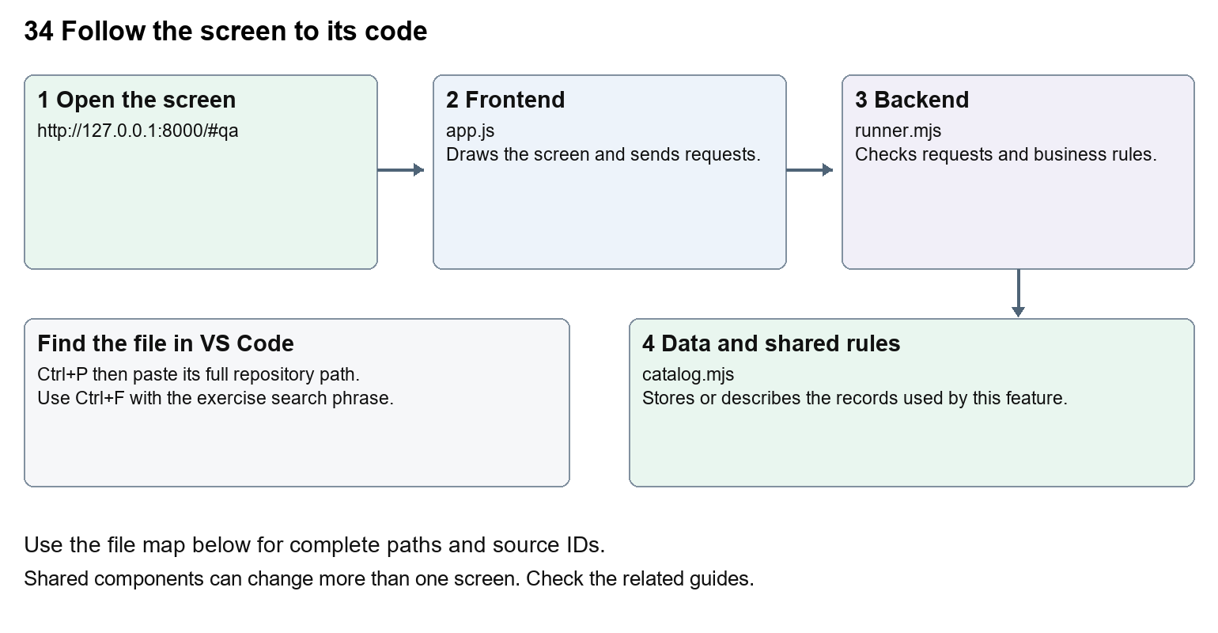
The diagram shows the file roles. The full paths below are what you paste into Ctrl+P.

Find the files in VS Code
Role | File and source ID | What it does
Screen | S0696 app.js | Main UI or route for this topic
Server | S0710 runner.mjs | Endpoints or server rules
Data | S0702 catalog.mjs | Data shape or persistence structure

Screen S0696
public/app.js
Server S0710
server/runner.mjs
Data S0702
server/catalog.mjs
Use the HTML source buttons for full files. Word shows labelled extracts; individual Markdown guides contain complete primary files.

Follow the request and the records
1. QA and verification shows fixed suites supplied by catalog.mjs.
2. POST /api/qa/run validates the suite and optionally a proposal task id.
3. The runner chooses the original checkout or a separate proposal verification copy.
4. QA-agent runtime preparation restores .NET packages and locked frontend packages before model execution.
5. Logs, exit codes and structured status/report data identify passed, failed, cancelled or blocked work.

Read the code with an explanation
A checkout check evaluates the original Nexora source. Test this proposal evaluates an independent source copy associated with a task. Prepare test dependencies is a QA-agent option; setup success does not mean tests passed. If .NET assets or Playwright are missing, read the preparation log and structured blocked result. The runner must parse the model output status and report as well as the process exit code. catalog.mjs records allowed commands and timeouts rather than accepting arbitrary commands from a browser form.
Source reference S0696 company-dash/public/app.js
Extract from source line 53. A fragment from a long line is shown without the rest of that line.
0053 function qaView() {

index.html supplies markup and app.js renders browser views. Follow api() to the server route handler.
Source reference S0710 company-dash/server/runner.mjs
Extract from source line 92. A fragment from a long line is shown without the rest of that line.
0092 async prepareQaRuntime(run, cwd) {

The browser api() helper sends a method and local request token. app.mjs checks the route and calls the relevant service. Follow that call to understand SQL writes, process execution and filesystem changes.
Source reference S0702 company-dash/server/catalog.mjs
Selected opening lines with their original numbers. The complete file is in the HTML source library.
0001 export const areas = ['All Nexora', 'CRM', 'Portal', 'Website / CMS', 'Platform'];
0002 export const agents = [
0009 ];
0010 export const suites = [
0017 ];

store.mjs defines SQLite history tables. catalog.mjs and config.mjs define configuration; repository.mjs records fingerprints. Trace each key into its service before assuming it is a stored table.

Make or trace your first change
1. Press Ctrl+P and open server/runner.mjs.
2. Press Ctrl+F and search for prepareRuntime. In this snapshot it appears at line 42.
3. Read-only exercise: trace prepareRuntime from enqueue to dependency setup. Find where setup failure prevents model execution, then compare a structured report with a process exit code.
4. Record the file, request path and server handler you found. This exercise is read-only; no stored records need to change.
Extract from source line 42. A fragment from a long line is shown without the rest of that line.
0042 enqueue({ task, suite, targetTask, prepareRuntime = task?.agent === 'qa' }) {

These exercises have not been applied to the application. Their search phrases are verified against the captured source. Line numbers can move; the phrase and file path are your main navigation aids.

Check a change and diagnose problems
Confirm the original screen still loads, the changed words appear in the intended place, and another screen using the same component still behaves correctly. If an action fails, inspect the browser Network response, the relevant helper and server validation message. Use the common error table at the beginning of the manual. Reload on a version conflict instead of removing the version check.
A syntax error after a text edit usually means a quote, brace or closing tag changed. Compare your diff with the original. An unchanged browser result can mean the wrong port, a saved published configuration overriding a default, or a running API that has not reloaded.

Understand the current limits
The command center serializes its own checks, but other tools can still occupy test ports. Browser suites use the Nexora runner and disposable test databases; proposal fixtures do not create persistent shared CRM records. Documentation QA does not rerun these product suites.

Continue learning
Related guides 30 Nexora backend database and maintenance, 33 Company Dash tasks agents and handoffs, 35 Company Dash proposal review and integration.

